Writing 1 HOUR
TASK 01:
You should spend about 20 minutes on this task.

The pie chart shows the amount of money that a children's charity located in the USA spent and received in one year. Summarise the information by selecting and reporting the main features and make comparisons where relevant.

Write at least 150 words.
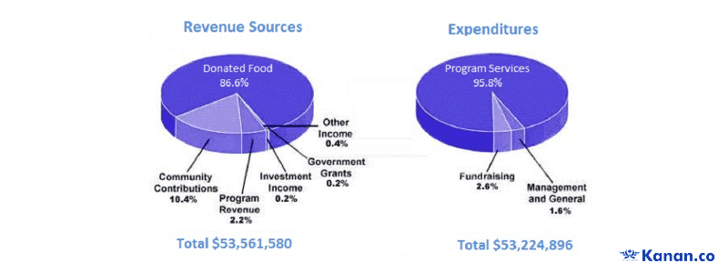
Mizan’s Care
TASK 02:
You should spend about 40 minutes on this task.
Some people argue that the government should play a larger role in regulating the economy and protecting workers’ rights, while others believe that the free market is most efficient and effective way to run an economy. Discuss both views and give your own opinion.
Write at least 250 words.

Writing 1 HOUR
TASK 01:
You should spend about 20 minutes on this task.

You recently started commuting to work by bicycle and discovered that there is a problem with bicycle parking near the building where you work.
Write a letter to the building manager. In your letter,
- explain the reason for using a bicycle to commute
- mention what problems you have encountered with parking
- what you recommend to solve the problems

Write at least 150 words.

You do NOT need to write any addresses.
Begin your letter as follows:
Dear Sir or Madam,

TASK 02:
You should spend about 40 minutes on this task.
Some people argue that the government should play a larger role in regulating the economy and protecting workers’ rights, while others believe that the free market is most efficient and effective way to run an economy. Discuss both views and give your own opinion.
Write at least 250 words.

